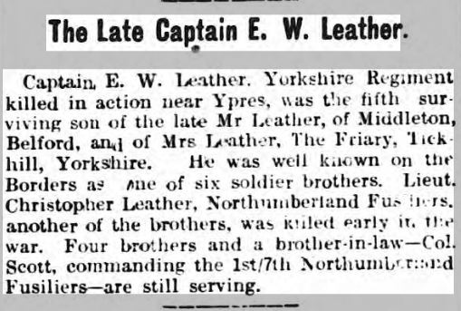
The Berwick Advertiser - Friday 30 April 1915
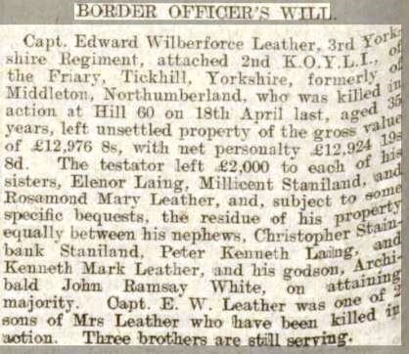

Berwickshire News and General Advertiser - Tuesday 13 July 1915

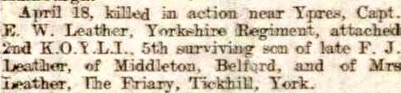
Berwickshire News and General Advertiser 16th November 1915.

